**BUILD AND DEPLOYMENT PROCESS GUIDELINE**

**Version 1.1**

**Prepared by**



**ABM Knowledgeware Ltd.**

ABM house Plot No.268, Linking Road, Bandra (West), Mumbai- 50

**Website**: [www.abmindia.com](http://www.abmindia.com)

**Confidential & Proprietary:**

****This is a confidential document of ABM Knowledgeware Limited. No part of this publication may be reproduced, stored in a retrieval system or transmitted in any form or by any means, whether electronic, mechanical, photocopying, recording or otherwise, without the written permission of ABM Knowledgeware Limited. This document includes confidential information and shall be used for the sole purpose of evaluation of the proposal. All the product names included in this document, if any, are registered trademarks of the respective company.

**ABM Knowledgeware Limited**

Head Office: ABM House, Plot No. 268, Linking Road, Bandra (West), Mumbai- 400 050

|  |  |  |  |  |  |  |  |  |  |
| --- | --- | --- | --- | --- | --- | --- | --- | --- | --- |
| Document Revision History | | | | | | | | | |
|  |  | **Author Details** | |  | **Review Details** | | **Approver Details** | |
| **Sr. No** | **Version** | **Created By** | **Creation Date** | **Changes incorporated in briefs** | **Reviewed by** | **Reviewed Date** | **Approved by** | **Approved Date** |
| **DD-MMM-YY** | **DD-MMM-YY** | **DD-MMM-YY** |
| 1 | 1.0 | Sanket Joshi | 03-12-18 | Build deployment process guideline added. |  |  |  |  |
| 2 | 1.1 | Sanket Joshi | 06-12-18 | Deployment process updated. |  |  |  |  |
| 3 | 1.2 | Sanket Joshi | 16-01-19 | Jasper Report copy step added. |  |  |  |  |
|  |  |  |  |  |  |  |  |  |
|  |  |  |  |  |  |  |  |  |
|  |  |  |  |  |  |  |  |  |
|  |  |  |  |  |  |  |  |  |
|  |  |  |  |  |  |  |  |  |

Table OF Contents

1 Prerequisites & Mandatory Guidelines for development team 4

2 Prerequisites & Mandatory Guidelines for build team 4

3 Steps for daily scrum builds 4

4 Jenkins environment 7

# Prerequisites & Mandatory Guidelines for development team

* Test your all changes locally before committing source to SVN.
* Do not forget to commit all dependant and newly added files.
* Before committing any changes in entity classes review your code from your lead and take approval of DB team (Shamik and Nilima).
* Developer will not commit any change during build process.
* Send email for any configuration related changes to Build Team and all developers.

# Prerequisites & Mandatory Guidelines for build team

* Before sending any build inform whole development & testing team on mail.
* Any changes related server configuration should be accepted only on mail.
* In case of failure due to any coding issue please contact respective developers.
* In case of failure in database related build please contact database team.
* For any Application Server or Jenkins related issue contact Sanket/Lalit/Vardan.
* After successful build and deployment inform development, testing and production team with latest SVN tag released and following Build Template on mail.



# Steps for daily scrum builds

1. Disable applications by using WildFly server administration console –
   * Service/Portal WildFly Console URL – <http://192.168.100.157:10000>
   * Username/Password: PRODUCTADMIN/ PRODUCTADMIN
   * Login to WildFly server administration console and navigate to Deployments

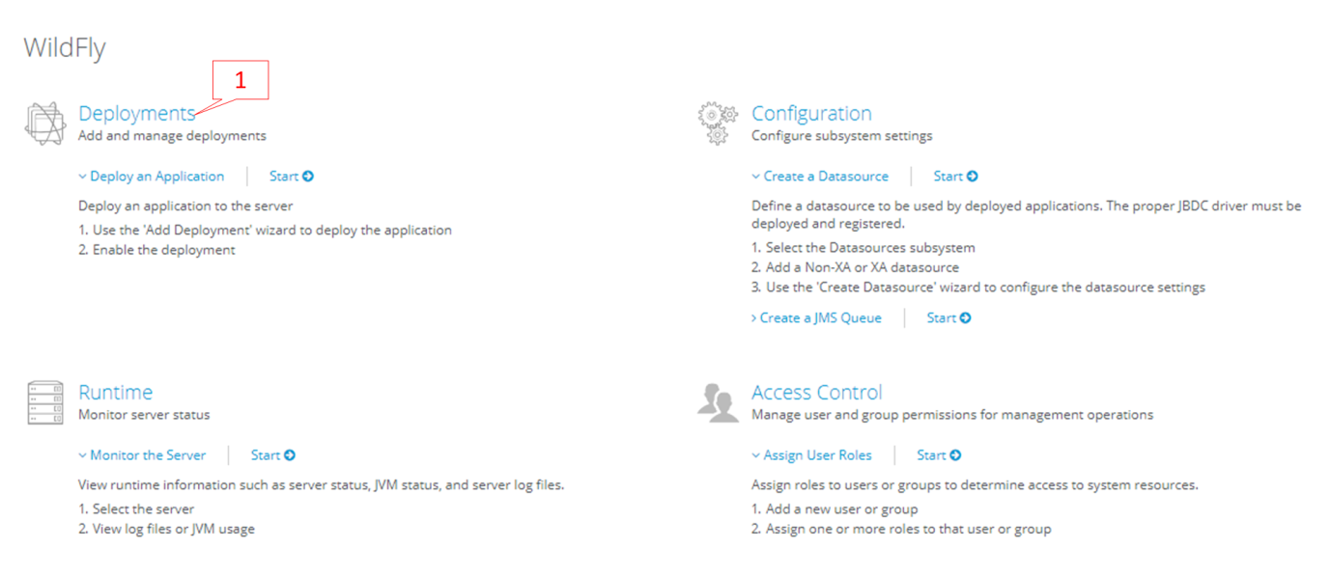

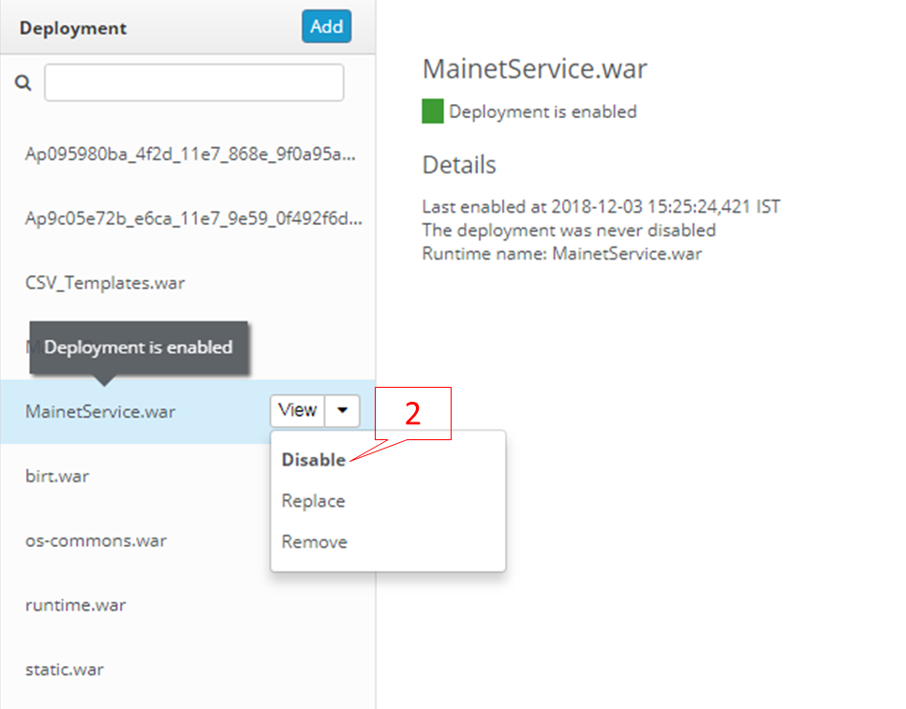

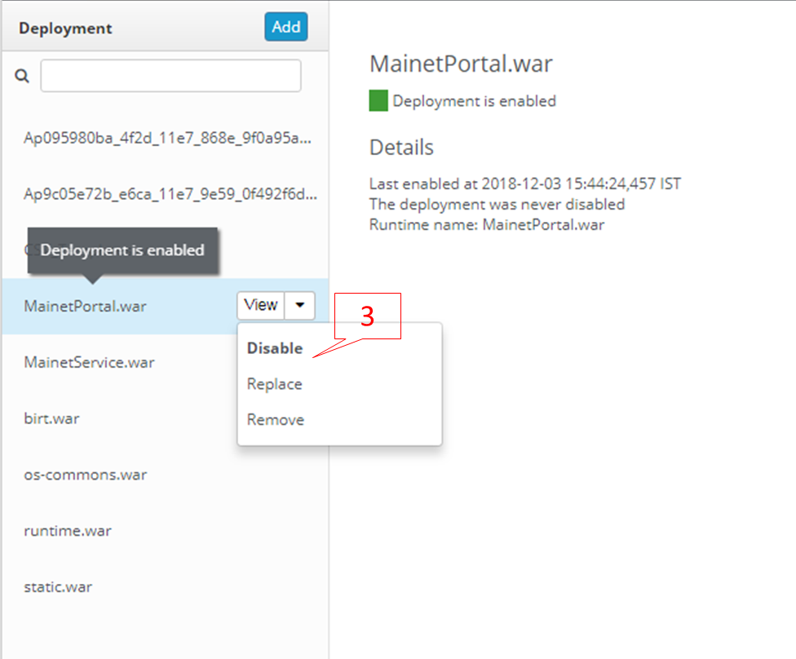

* + BPM/DMS WildFly Console URL – <http://192.168.100.198:9991>
  + Username/Password: admin/admin

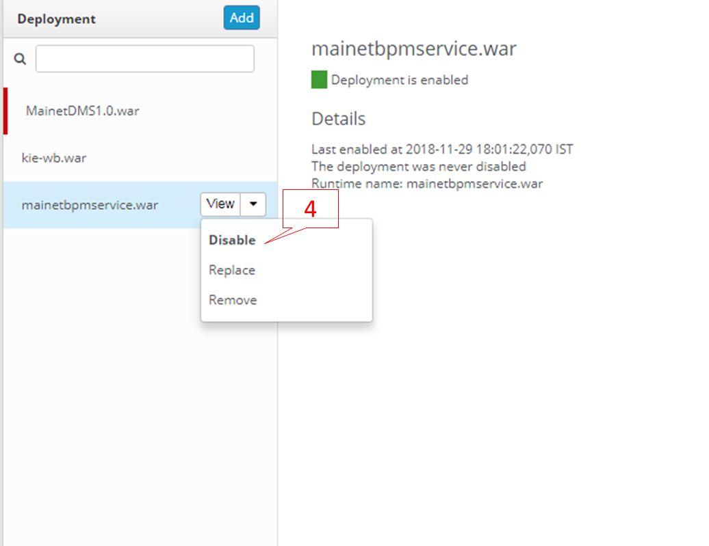

1. Then run Liquibase job for Service and Portal with builds required parameters. (This is separate database , currently copy of production)
   * Service DB job name - **Dev_DB_MainetService**
   * Portal DB job name - **Dev_DB_MainetPortal**
   * For both jobs select ‘**update**’ in **LQB_OPTIONS**.
2. Replace updated Label property files. (Always refer latest version from SVN only )
   * Mainet_Label (mainetPortal-web\src\main\webapp\WEB-INF\i18n)
   * Product_Service_Label (MainetServiceWeb\src\main\webapp\WEB-INF\i18n)
   * Product_Service_Label\tempfiles\jasperReport (MainetServiceWeb\src\main\webapp\jasperReport)
3. Update server configuration files if any change request by any developer and restart application servers.
4. Then run Application job.
   * Service application job name - **Dev_App_MainetService**
   * Portal application job name - **Dev_App_MainetPortal**
   * BPM application job name - **Dev_App_MainetBPMService**
   * DMS application job name - **Dev_App_MainetDMSService**
5. After successfully execution of all deployment jobs, enable all applications which were disabled (at Step 1) by using WildFly server administration console.

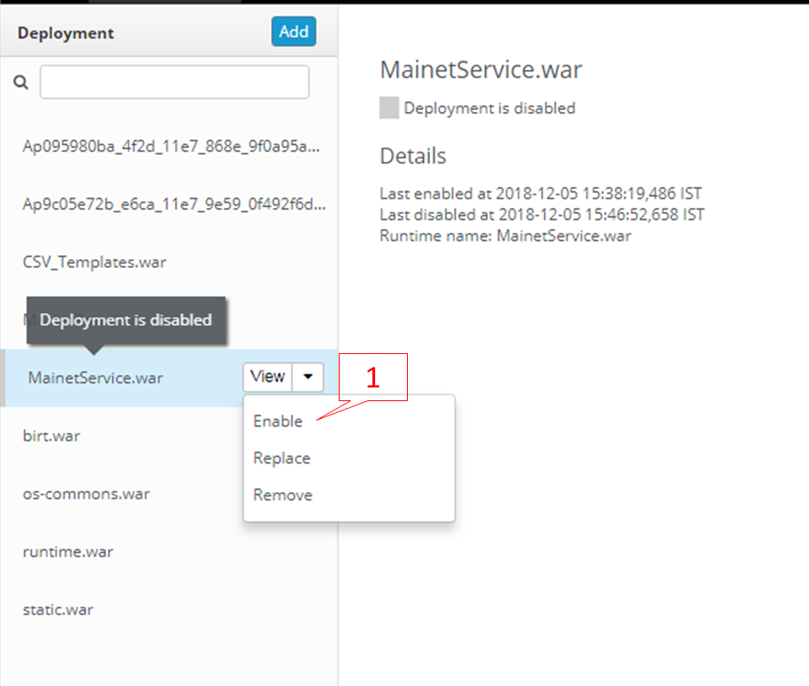

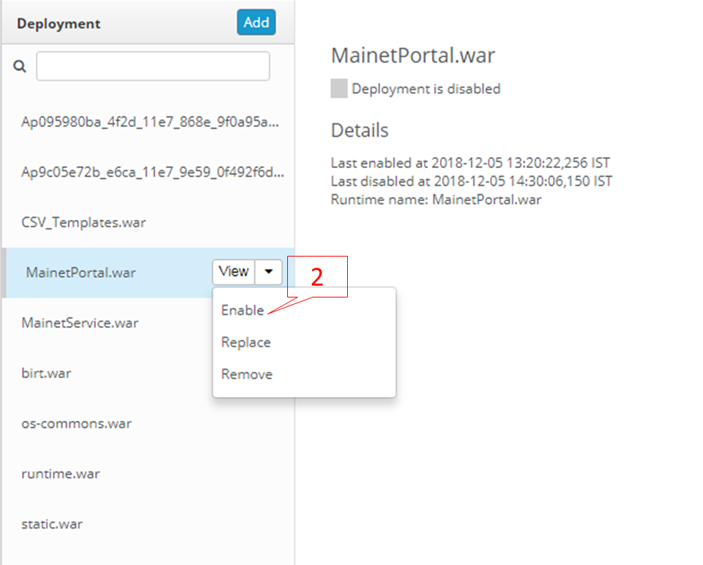

# Jenkins environment

URL - <http://192.168.100.157:8080>

Username – ScrumBuild

Password – ScrumBuild@157!